ITUE203: WEB DEVELOPMENT FRAMEWORKS 25CS106– Yana


Faculty of Technology and Engineering

Chandubhai S. Patel Institute of Technology (CSPIT) Department of Computer Science & Engineering

Laboratory manual
Academic Year | : | 2026-27 | Semester | : | 3rd

Practical - 06

PROBLEM STATEMENT :
Display event lists, student profiles, notices, or FAQs from external JSON files using Fetch API. Implement dynamic rendering, search, filter, sorting, and pagination.
OBJECTIVE:
To develop a dynamic web application that fetches external JSON data using the Fetch API and displays it on a webpage. Implement search, filtering, sorting, and pagination using JavaScript array methods, along with loading and error handling.
OUTPUT:
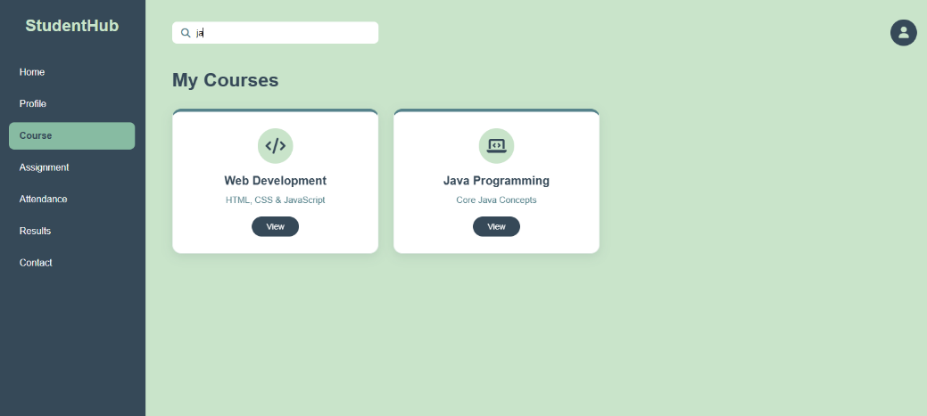
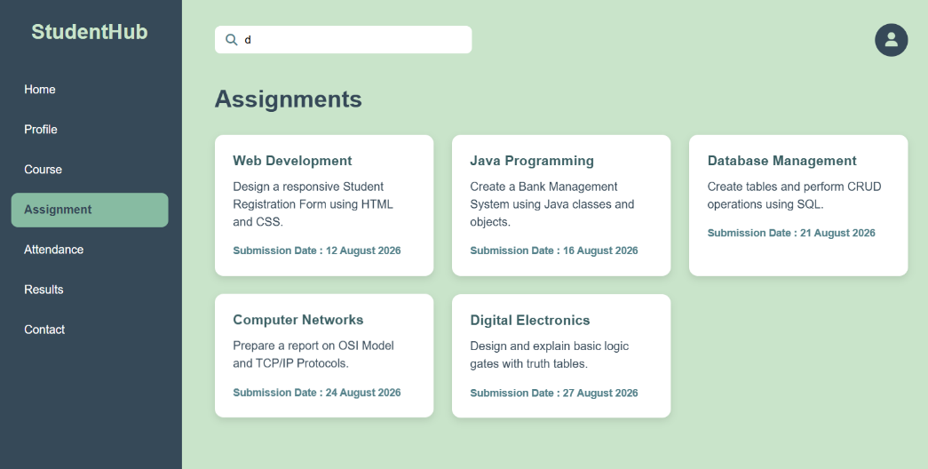
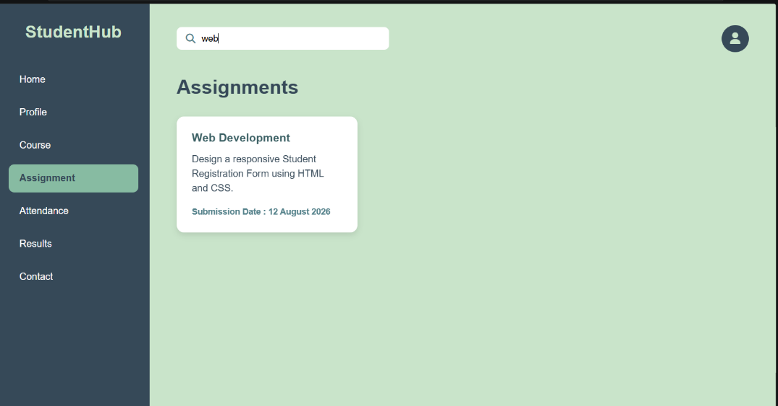
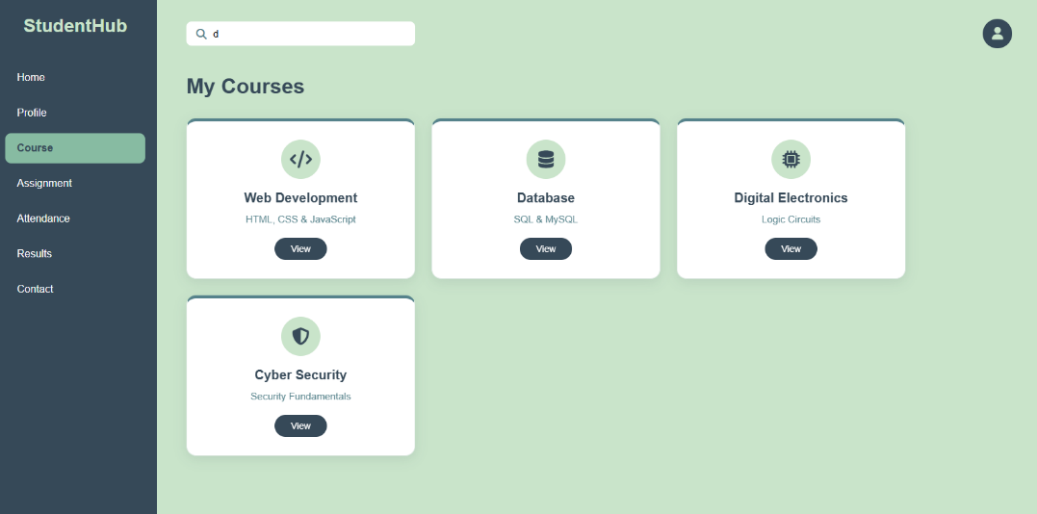

LEARNING OUTCOME:
- Understand how to fetch, parse, and render JSON data using the Fetch API.
- Implement search, filtering, sorting, and pagination using JavaScript array methods.
- Handle loading states and errors during data fetching.
- Maintain modularity by organizing JavaScript code into separate files.
- Develop dynamic and reusable frontend views for events, student profiles, and FAQs.

